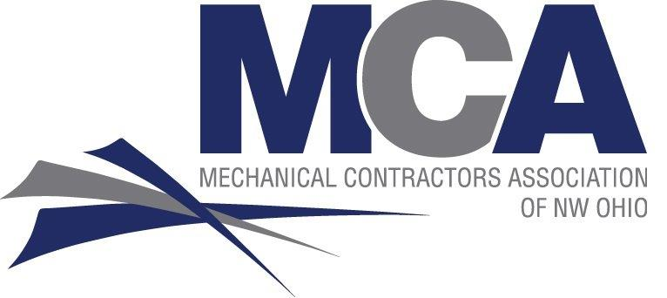
^{MCA of NW Ohio Golf Outing}
Friday, May 19, 2023
Belmont County Club, 29601 Bates Road, Perrysburg, OH 43551

- 7:30am Registration
- 8:30am Shot Gun Start
- 11:00am Lunch on the Course
- 2:00pm Cocktails, Grazing Stations, Awards, & Prizes

Registration Deadline: May 6, 2023
- Per Individual Player $125.00
- Golf for Team of Four $500.00
Please complete the following information:
Golfer #1 ____________________________________ Golfer #2 _________________________________
Golfer #3 ____________________________________ Golfer #4_________________________________

TOTAL ENCLOSED: $_______________________

Team Contact Information:

Name: ___________________________________ Phone Number: _____________________

Company: _____________________________ Email: ____________________________

Please return payment with form to:

MCA of NW Ohio. Inc.
7550 Caple Blvd
Northwood, OH 43619

Questions….
Anne Saloff 419.666-6900 or asaloff@mcanwo.org

-- Limited to the first 140 paid golfers.

